**EXCEPTION HANDLING**

**SYSTEM DEFINED EXCEPTIONS PROGRAM**

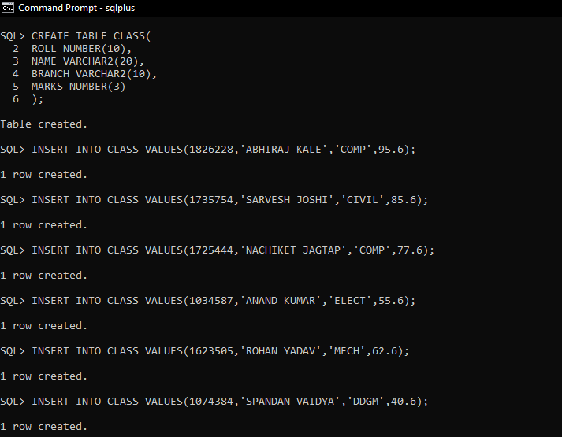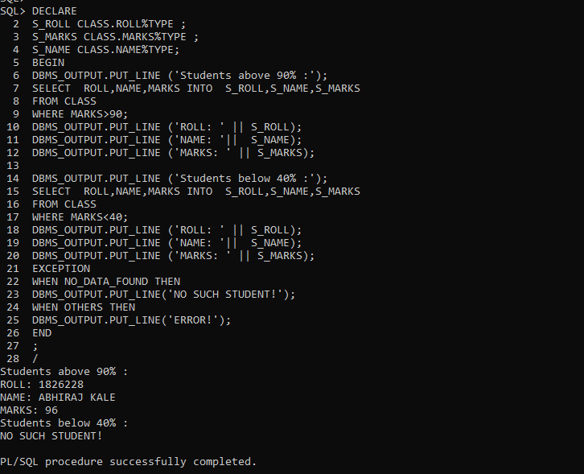

**USER-DEFINED EXCEPTIONS PROGRAMS**

